**Module 10 – Single Page Application framework – React**

1. **ReactJS-HOL**

**What is SPA and Its Benefits**

SPA stands for Single Page Application. It’s a type of web app where only one HTML page loads, and when the user clicks or navigates, the page updates using JavaScript without reloading the whole page.

Some benefits of SPA are:

* Navigation feels faster since only the content changes, not the whole page
* The user experience is smoother
* It puts less load on the server
* It performs well, especially for frontend-based apps

**What is React and How It Works**

React is a popular JavaScript library created by Facebook. It helps developers build user interfaces, especially for SPAs.

How React works:

* Everything in React is made of components, which are like reusable blocks of code
* It uses something called the Virtual DOM to update the page quickly
* Instead of telling the browser how to update, we just describe what the UI should look like, and React takes care of the rest (this is called declarative programming)

**Difference Between SPA and MPA**

| **Feature** | **SPA** | **MPA** |
| --- | --- | --- |
| Page Loading | Loads a single HTML page | Loads multiple HTML pages |
| Speed | Faster and smooth | Slower (refreshes every time) |
| Coding Style | More JavaScript logic, uses APIs | Traditional full-page routing |
| SEO | Harder to optimize | Easier to make SEO-friendly |

**Pros and Cons of SPA**

**Pros:**

* Very responsive
* Needs fewer server requests
* Smooth navigation and transitions

**Cons:**

* SEO is difficult
* The first page load might take longer
* It won’t work properly if JavaScript is disabled

**About React**

React is used to create UI (User Interface). It’s open-source and widely used in modern web development. Instead of writing big files of HTML and JavaScript separately, React lets us combine everything into reusable components.

React encourages:

* Writing code in components
* Managing small parts of the UI separately
* Using tools like hooks and states for interactivity

**What is Virtual DOM**

Virtual DOM is like a copy of the actual DOM. React updates this copy first, then checks what’s changed, and finally updates only the changed parts in the real DOM.

This helps in:

* Faster rendering
* Better performance
* Avoiding full-page reloads

**Features of React**

Some main features of React are:

* **Component-Based**: UI is divided into small, reusable parts
* **JSX**: Combines JavaScript and HTML-like code
* **Virtual DOM**: Updates only what's changed
* **One-Way Data Flow**: Data flows in one direction, making it easy to track
* **Hooks**: Makes functional components more powerful
* **Fast Rendering**: Thanks to Virtual DOM
* **Large Ecosystem**: Lots of community support and libraries

**Create a new React Application with the name “myfirstreact”, Run the application to print “welcome to the first session of React” as heading of that page.**

**Structure:**

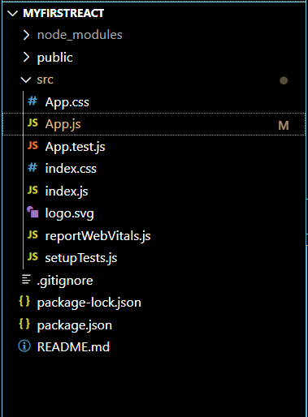

**App.js:**

import React from 'react';

function App() {

  return (

    <div>

      <h1>Welcome to the first session of React</h1>

    </div>

  );

} export default App;

**Output:**

